8x8 Teensy Audio Board  
Commissioning Notes

V1.0 April 2025

*These notes explain matters relevant to building and commissioning the main CODEC board and Wing boards.*

*There is relevant information in the Technical Notes that is not duplicated here.*

*Project schematics and component datasheets may also be valuable resources. Page references are to the TVL320AIC3104 datasheet.*

# Stacking

12x3mm spacers should be used for stacking boards. The ones with 6mm male screw threads provide more secure mounting than those with 3mm threads.

Constructors should ensure that the 5V power supply is adequate.

If more than two boards are stacked or significant power is drawn on the V+ and V- lines (when connected to VIN and the on-board -5V supply), the POWER header should be used rather than the USB connector on the Teensy, as the current draw is likely to approach or exceed 0.5 amps.

Where the POWER connector is used, care should be taken to ensure correct orientation of the IDC cable (see Connectors, below).

Where the USB connector is used for an audio connection and +5V power is being supplied through the POWER connector, the instructions on the Teensy website for non-USB powering should be followed - <https://www.pjrc.com/store/teensy40.html>

## On-board jumpers

To function correctly each board in a stack must be jumpered to a different address.

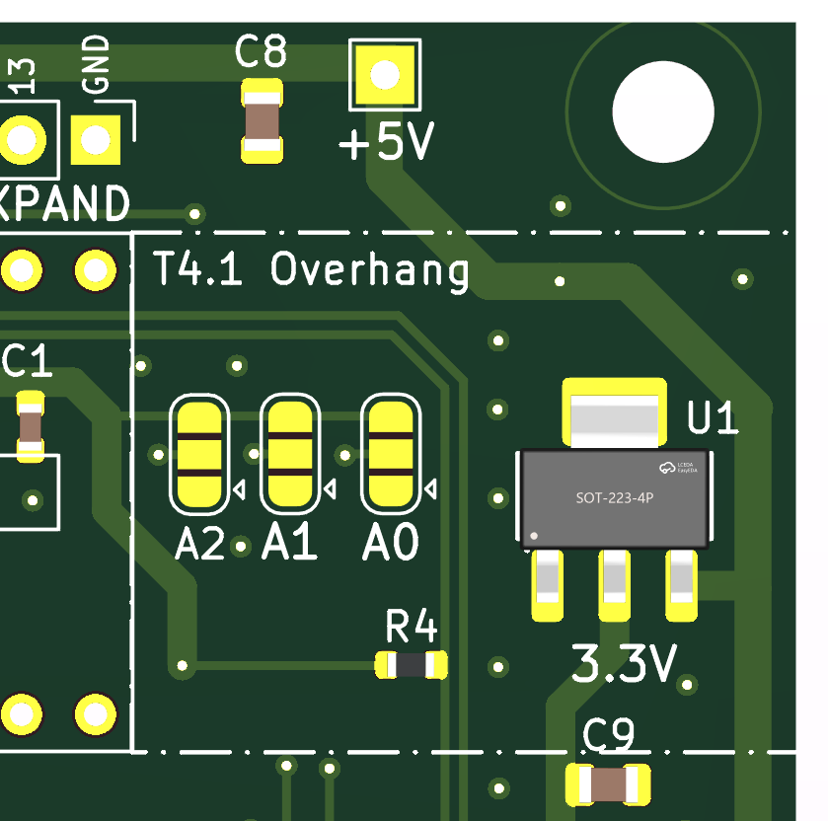This is accomplished by bridging the appropriate pads on the A0 A1 and A2 jumpers near the end of the Teensy headers. The pair of pads near the Ax legends is 0 and the opposite pair is 1.

For the first board, the jumpers are:  
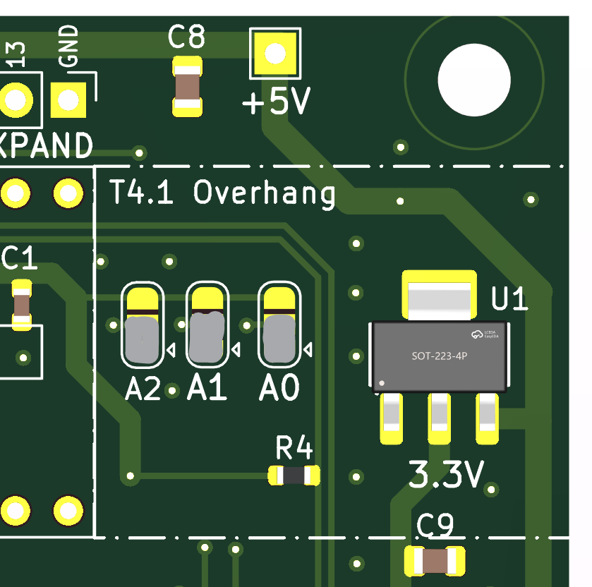

For the second board:

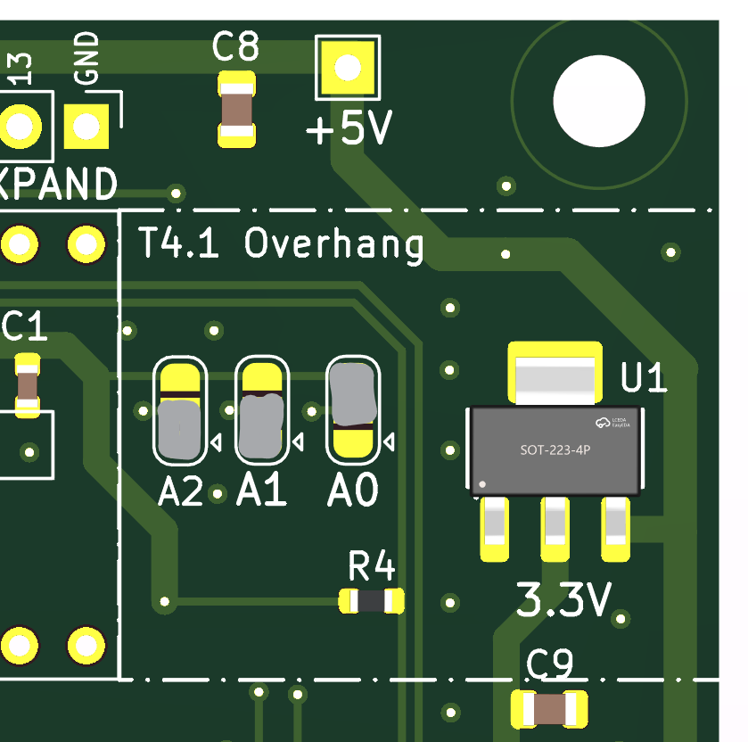

The input and output channel numbers are assigned using these addresses. The physical stacking order does not matter.

## 32x32 mode (Rev L or later ONLY)

The DI and DO jumpers on the rear of the board should be cut on the third and fourth boards in the stack and connected: DI – Teensy GPIO6 and DO – Teensy GPIO9.

Jonathan Oakley’s Multi-TDM driver is required if more than two boards are stacked. <https://github.com/h4yn0nnym0u5e/Audio/tree/feature/multi-TDM>

# Input Configuration

When a *differential* input signal is applied to a CODEC programmed as *single-ended,* somereflection will occur into the other channel. This appears to be because VCM is connected to the negative PGA input in single ended mode, providing a path between channels (Fig 10-13, p.36).

To avoid this issue, program *differential* mode for all inputs for both single-ended and differential signals unless the CODECs negative input pins are not used (i.e. even pins on the input connector are left unconnected).

All wing boards should be programmed with *differential* mode.

When *single-ended* mode is used, all negative input signals should be left unconnected.

# Connectors

### Main Board

The four 6x2 right-angle IDC input and output connectors mount on the top of the PCB.

The 14-pin Teensy headers are supplied with long pins to enable stacking multiple boards. If stacking is not required, the pins may be trimmed after soldering.

The 5x2 power connector is a long-pin female type, which mounts on the REAR of the PCB to facilitate stacking. To protect against incorrect orientation of the IDC power cable the outer shell of a shrouded 5x2 male connector can be slipped over the pins. Some countersinking of the pin holes on the underside of the shell may be required for the shroud to fit snugly to the PCB.

For 8x8 configurations the POWER connector can be substituted with a 5x2 shrouded male IDC connector.

The EXPANSION header does not need to be connected between CODEC boards.

### Wing Boards

The IDC connector mounts on the top of the PCB for all Wing boards.

On the XLR Input/Output board:

* Input (female) connectors mount on the TOP of the board.
* Output (male) connectors mount on the BOTTOM of the board

On the TRS board:

* The 1/8” headphone jacks are only required for the output configuration.

The channel numbering on the 6x2 IDC connector for inputs and outputs is different. Pin 3 is the first positive *input* pin, and the last positive *output* pin. The ground and power pins are the same on input and output connectors.

### Input and Output Connectors (2 x6)

|  |  |  |  |  |  |  |
| --- | --- | --- | --- | --- | --- | --- |
| **Pin** | **Input** | **Output** |  | **Pin** | **Input** | **Output** |
| 1 | V+ | V+ |  | 2 | V- | V- |
| 3 | IN1+ | OUT4+ |  | 4 | IN1- | OUT4- |
| 5 | IN2+ | OUT3+ |  | 6 | IN2- | OUT3- |
| 7 | IN3+ | OUT2+ |  | 8 | IN3- | OUT2- |
| 9 | IN4+ | OUT1+ |  | 10 | IN4- | OUT1- |
| 11 | AGND | AGND |  | 12 | AGND | AGND |

### Power Connector (2x5)

|  |  |  |  |  |
| --- | --- | --- | --- | --- |
| **Pin** | **Signal** |  | **Pin** | **Signal** |
| 1 | GND |  | 2 | GND |
| 3 | GND |  | 4 | GND |
| 5 | VIN (+5V) |  | 6 | VIN (+5V) |
| 7 | V- (analogue) |  | 8 | V- |
| 9 | V+ (analogue |  | 10 | V+ |

### Main Board Connector Types

|  |
| --- |
| **Connectors** |
| **Input and output (Main and Wing boards)** 2 x 6 pin 2.54mm shrouded right-angle male IDC header  Right angle connectors are required if stacking several boards. |
| **Power input** Stacked: 2 x 5 pin 2.54mm long pin female header  Single board: 2 x 5 pin 2.54mm male shrouded IDC header  Mounting a long-pin female header on the underside of the PCB allows power pins to stack. This is only required if V+ and V- are used. The Teensy headers transfer 5V and 3.3V power. |
| **Teensy and board interconnect**  2 x single row 14 pin 2.54mm female header  Long pins if stacking boards. |
| **Expansion**  14 pins, including 5V, 3.3V power, ground and pin 22 reset.  Pinouts are marked on the underside of the PCB  The expansion header does not need to be connected between boards. |

### Expansion header

|  |  |
| --- | --- |
| **Pin** | **Signal** |
| 14 | VIN |
| 13 | GND |
| 12 | 3V3 |
| 11 | 2 |
| 10 | 22 RST |
| 9 | 5 |
| 8 | 8 SCL |
| 7 | 7 SDA |
| 6 | 17 |
| 5 | 16 |
| 4 | 15 |
| 3 | 14 |
| 2 | 13 |
| 1 | GND |

GPIO Pins 2, 13,14,15 and 16 are uncommitted on the Expansion header.

The I2C bus and soft Reset signal are extended on the Expansion header as well as the Teensy header for boards.

## Wing Board Components

Electrolytic capacitors are polarity-sensitive. The white stripe on the capacitor matches with the white semicircle on the PCB. Resistors are not polarised.

All wing boards, other than the amplified TRS board, are designed for through-hole components.

The boards have decoupling capacitors and discharge resistors to reduce pops when hot-plugging.

1uF or 10uF electrolytic capacitors may be used for all inputs (the ADC input impedance is > 30 K ohms).

On outputs, 100uF capacitors provide better low frequency response when driving low-impedance loads such as headphones or 600 ohm balanced lines.

* 10uF or 100uF capacitors are 6.3 x 2.5mm, 10V or greater.
* 50V capacitors are required for phantom powering.
* 1uF capacitors are 5 x 2.5 mm, 10V or greater.
* Resistors are metal film, 5%, ¼ Watt.

All wing boards may be used in single-ended or differential mode. When used in single-ended mode, the coupling capacitors for the negative inputs should be omitted (see Fig 10-13 p.36) to allow these signals to float (see Input Configuration, below).

For *output* boards the 47 Ω current-limiting resistors R1-R8 are required to protect against single-ended (ring shorted to ground) cables.

### TRS

The TRS board hosts four inputs or outputs.

For *input* boards the current-limiting resistors R1-R8 may be omitted and the pads linked.

The [Amphenol](https://au.mouser.com/manufacturer/amphenolaudio/) [ACJM-IH](https://au.mouser.com/ProductDetail/Amphenol-Audio/ACJM-IH?qs=t8VhaDIDl4v4EBLCsB4y7Q%3D%3D), [Neutrik](https://au.mouser.com/manufacturer/neutrik/) [NMJ4HFD3](https://au.mouser.com/ProductDetail/Neutrik/NMJ4HFD3?qs=%252B86TLfaev2%252B4Sd%2FGmMLlUg%3D%3D) or compatible switched TRS connectors are mounted on the top of the board for both input and output applications.

If grounding of unused *input* channels is desired, jumpers on the underside of the PCB may be shorted. The jumpers MUST be left open for output boards.

Note that the channel order is different for input and output use.

1/8” (CUI SJ1-353xNG) headphone sockets are provided in parallel to the ¼” TRS sockets. The current-limiting resistors are bypassed. These are only required for the output configuration.

### XLR

The XLR board has four connectors – female for inputs (Neutrik NC3FAAH or equivalent, mounted on the top of the PCB) or male for outputs (NC3MAAH or equivalent, mounted on the underside of the PCB.)

### Combo XLR

This input board has four XLR combo connectors (Neutrik NCJ6FI-H, NCJ9FI-H or REAN equivalents) with decoupling capacitors and discharge resistors to reduce pops when hot-plugging.

## Additional designs

### Amplified TRS

Where higher-level outputs are required for professional applications the Amplified TRS board provides an additional 3x gain. The maximum levels are 2.1 VRMS (6V p-p) single ended and 4.2 VRMS (12V p-p) differential. The board will drive 600 Ω lines to +8dBm, but is not recommended for low impedance headphones.

SMD components are used on this board to allow a more compact layout.

The LM2776 voltage inverter should be installed on the Teensy main board and Vin linked to V+. Alternately, suitable V+ and V- supplies may be provided via the Power connector.

If V+ and V- are greater than 5V, the gain may be increased to suit the op amps’ maximum output swing and drive capability. The maximum supply voltage of the op amps needs to be at least equal to the sum of the supply rail voltages.

### XLR Phantom input

The phantom-powered XLR input board has four female connectors (Neutrik NC3FAAH or equivalent).

A 2-pin header is provided for an external phantom power source. 6.8k phantom power resistors are specified for 48V operation. The values may be reduced for lower voltages.

The board has 50V decoupling capacitors.

# Using the Boards

## Software

The examples provided with the control_TLV320AIC3104 library demonstrate the basic requirements: of using the control_TLV320AIC3104 object to enable the CODECs and TDM transfers.

To simplify coding of multiple inputs and outputs, dynamic AudioConnections are demonstrated.

Function references are in the readme.md file provided with the library.

As of Teensyduino 1.59 the standard TDM driver does not handle samples from odd numbered channels correctly. The TDMA driver supplied with the library does. It is believed that 1.60 will correct the issues, but a release date had not been set at the time of writing.

Jonathan Oakley’s Multi-TDM driver should also work with this hardware. <https://github.com/h4yn0nnym0u5e/Audio/tree/feature/multi-TDM>

The multi-TDM driver is required if more than two boards are stacked.